Tennessee Plays Hard – An Initiative to Show
the Importance of Play in the Early Years
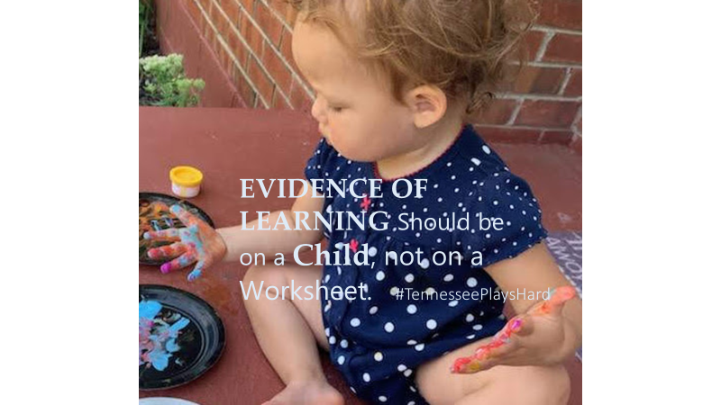

Early childhood educators largely agree, play in the early years is important. But, how important? Psychiatrist and author Kay Redfield Jamison implores, “Children need the freedom and time to play. Play is not a luxury. Play is a necessity.” Play is so imperative to a child’s well-being that the American Academy of Pediatrics released a report last year, https://pediatrics.aappublications.org/content/142/3/e20182058, that strongly endorses the important role of play in the lives of young children. The report suggests that pediatricians write “prescriptions” for young children to engage in more play and less structured, adult-directed, and academic focused activities.

As early educators, we get it. We know firsthand that play and learning are not mutually exclusive. Play is the vehicle by which children develop their physical, cognitive, emotional, social, and even moral capacities. We recognize that play promotes brain development, problem solving skills, initiation and memory, language acquisition, and concept formation. We understand that play promotes emotional and social well-being, acceptance, empathy, trust and respect for others.

In other words, play is indeed a necessity for children. TACEE wants early educators, parents, advocates, and friends to join in celebrating the importance of play with a new initiative: TENNESSEE PLAYS HARD. We ask that you share photos that illustrate the power of play on social media – Instagram, Twitter and Facebook, and use this hashtag, #TennesseePlaysHard. TACEE will do the same. Let’s show the world what play looks like in Tennessee.

